UNLOCKING INSIGHTS INTO THE GLOBAL AIR TRANSPORTATION
NETWORK WITH TABLEAU

1 INTRODUCTION
1.1 Overview
* Air Transportation involves visualizing data , cargo volumes, airport traffic, helping stakeholders gain a better understanding of the dynamic of the global air transportation network.
1.2 Purpose
* Use data visualization to uncover trends,patters,and correlations within the aviation industry ,enabling informd decision making.
2 PROBLEM DEFINING & DESIGN THINKING
2.1 Empathy map
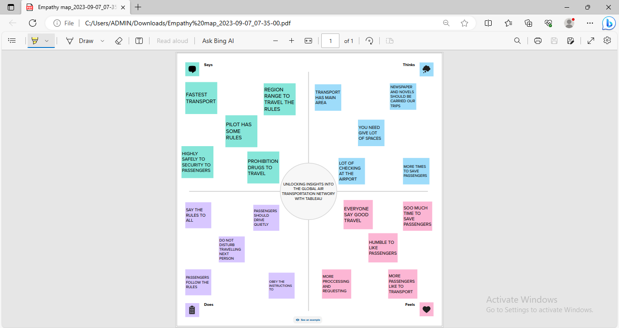

2.2 Ideation & Brainstorming Map

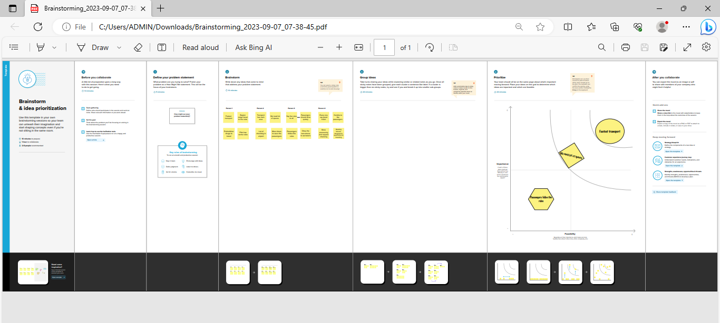

3 RESULT
The final findings shows how to analysing & understanding of the Air Transportation.
4 ADVANTAGES & DISADVATAGES
*Air travel is one of the fastest modes of transportation, allowing people and goods to reach their destinations quickly .
* Air travel is a major contributor to greenhouse gas emissions, leading to concerns about climate change .
5 APPLICATION
* Air transportation has a wide range of applications
Commercial aviation enables people to travel quickly and conveniently for business ,leisure or ,medical reasons.
6 CONCLUSION
* Global air transportation offers speed, accessibility, and connectivity, but it also poses related to the environment , cost ,and security .
7 FUTURE SCOPE
* Emerging markets and increased urbanization will drive demand for air travel, leading to the expansion of routes and infrastructure in various regions.

